

A Project Report On

**ToDo Application**

**By**

## Hadiya Shaikh M.E

### Batch: - 2020 – 5078

**Center: - Pune**

Under the Guidance of,

**Jayanth V.**

**Technical Trainer**

**EduBridge**

(School of coding)

**Introduction:**

This Project **Todo Application** has been developed on **Java, JSP and MySQL**. The main purpose for developing this project  Organizing your tasks with a list can make everything much more manageable and make you feel grounded. Seeing a clear outline of your completed and uncompleted tasks will help you feel organized and stay mentally focused.

As you cross items off your to-do list, you'll feel a sense of progress and accomplishment that can be missed when rushing from one activity to the next. The affirmation that you are making progress will help motivate you to keep moving forward rather than feeling overwhelmed.

Software Requirements:

Front end: Java/J2EE technologies (Servlet,JSP), HTML,

CSS, JDBC.

Back end: MySQL.

Server: ApacheTomcatv8.5V

IDE: Eclipse IDE for Java EE Developers

Browser: Best result on Google Chrome Operating System: Window 7

**Data Dictionary:**

**DataBase:**

create database demo;

use demo;

**User:**

**Table name: Users**

CREATE TABLE `users` (

`id` int(3) NOT NULL AUTO_INCREMENT,

`first_name` varchar(20) DEFAULT NULL,

`last_name` varchar(20) DEFAULT NULL,

`username` varchar(250) DEFAULT NULL,

`password` varchar(20) DEFAULT NULL,

PRIMARY KEY (`id`)

) ENGINE=InnoDB DEFAULT CHARSET=utf8mb4 COLLATE=utf8mb4_0900_ai_ci;

select * from FoodItems;

**Todo:**

**Table name: todos**

CREATE TABLE `todos` (

`id` bigint(20) NOT NULL AUTO_INCREMENT,

`description` varchar(255) DEFAULT NULL,

`is_done` bit(1) NOT NULL,

`target_date` datetime(6) DEFAULT NULL,

`username` varchar(255) DEFAULT NULL,

`title` varchar(255) DEFAULT NULL,

PRIMARY KEY (`id`)

) ENGINE=InnoDB AUTO_INCREMENT=8 DEFAULT CHARSET=utf8mb4 COLLATE=utf8mb4_0900_ai_ci;

select * from User;

# Modules and Description Of Todo Application Project:

## To-do Application Module:

In this modules, some sub modules are available:

* Login
* Signup
* To-do Form
* To-do List
* Log out

1. **Login:**

In the below screenshots fig a.shows the Login form of Todo Application.

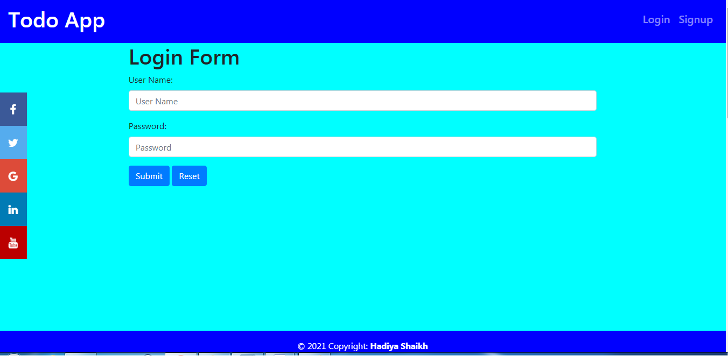

***Fig a. Login Form***

1. **Signup:**

In the below screenshots fig b. shows the User Register From

* First_name
* Last_name
* Username
* Password

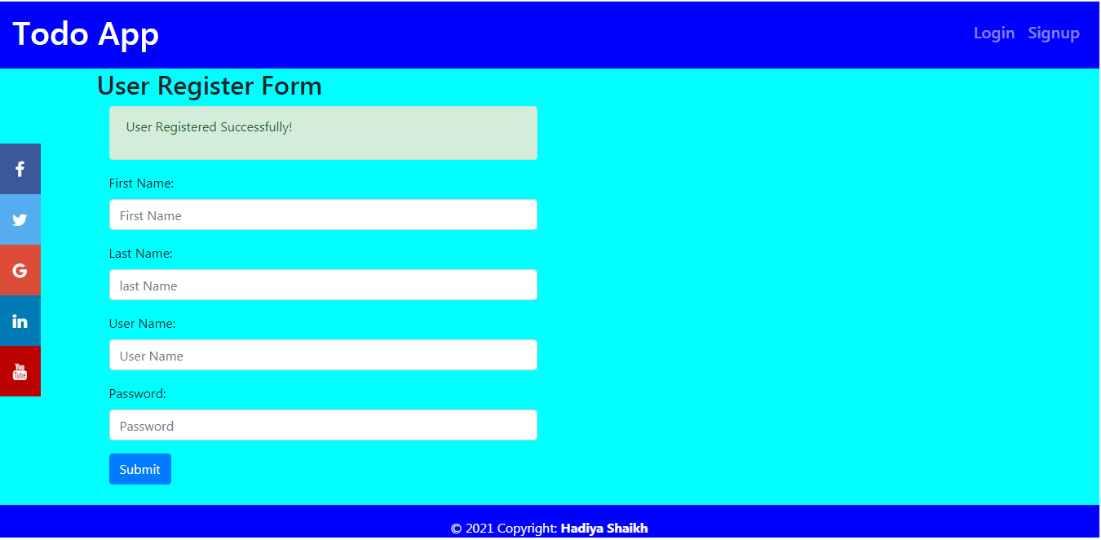

***Fig b. User Register Form***

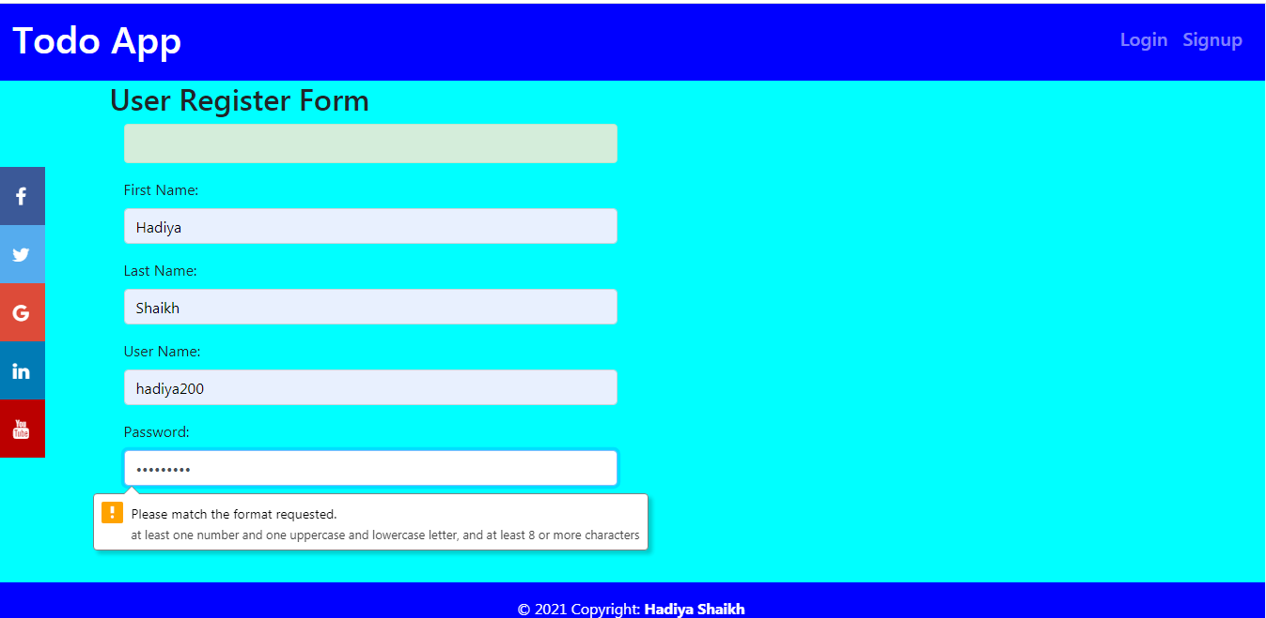

***Fig b(1)***

Password filled must matching format if the filled matches the condition it will accept the **User Register Form.**

After that I have to Login to To-do Application then page will redirect to **Login page**.

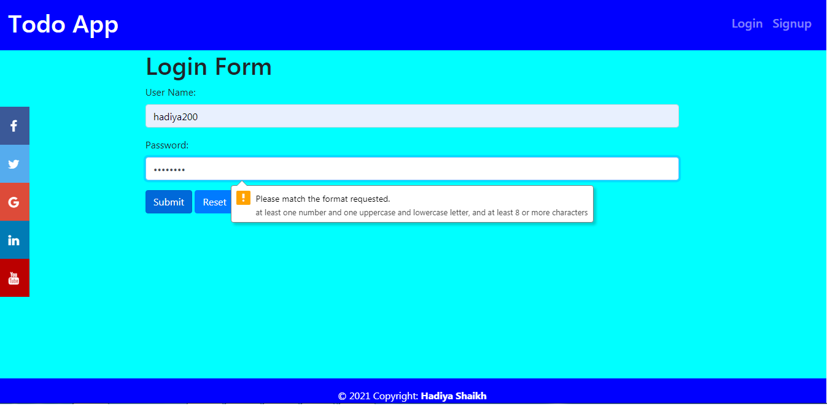

***Fig c. Login Form of Password Validation***

1. **To-do Form**

In the below screenshot shows the List of To-dos .

* Add To-do
* Show To-do

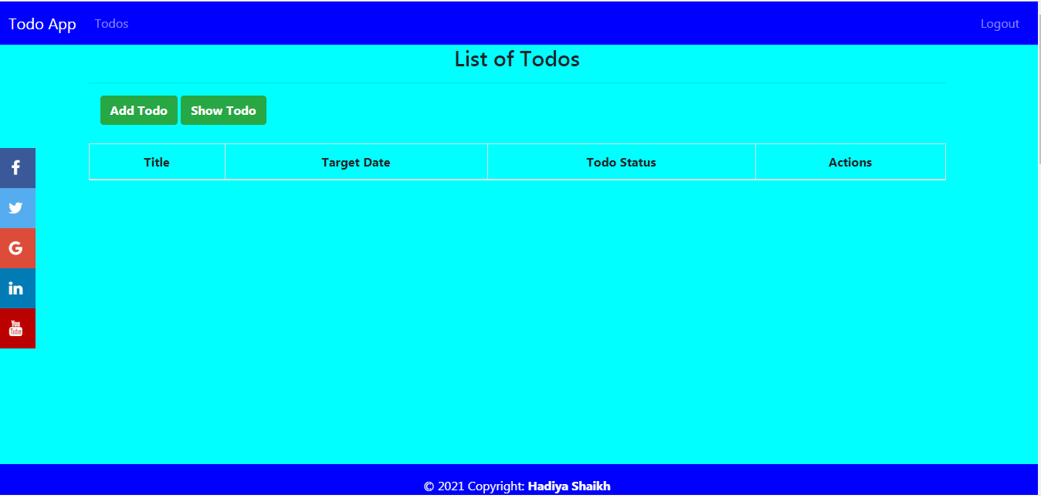

***Fig d. List Of Todos***

1. **To-do List**

* **Add To-do:**

After click on Add To-do button it will open the form to add new to-dos.

Fill the detail and click on save button all information will added to to-dos.

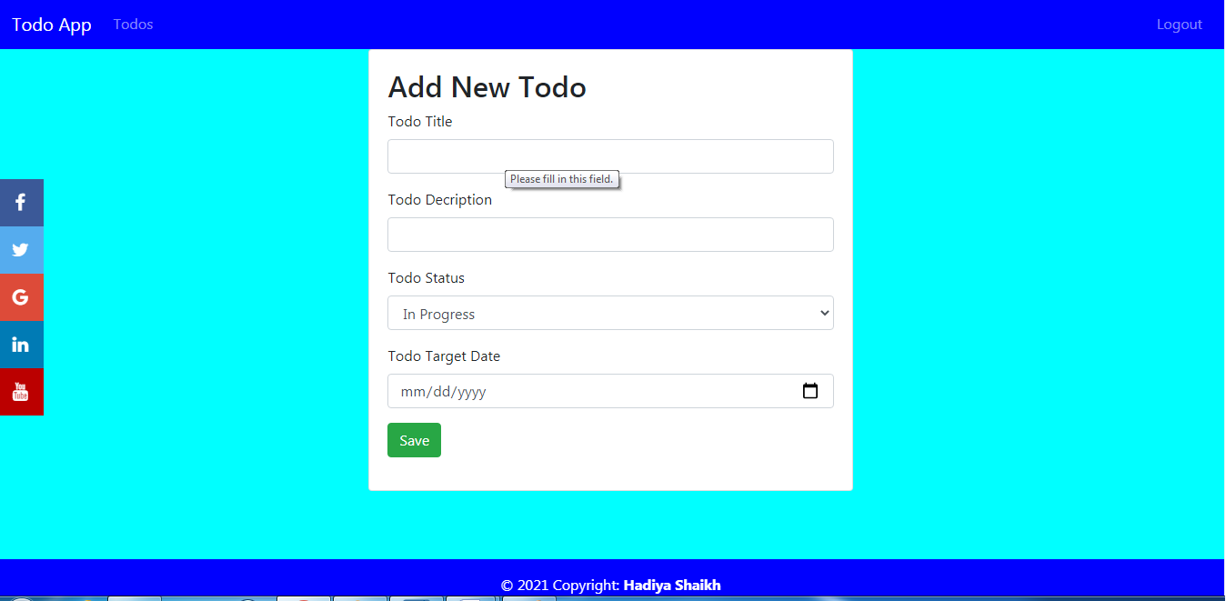

***Fig e. Add New To-do***

* **Show To-do:**

After click on Show button it will display a list of To-dos.

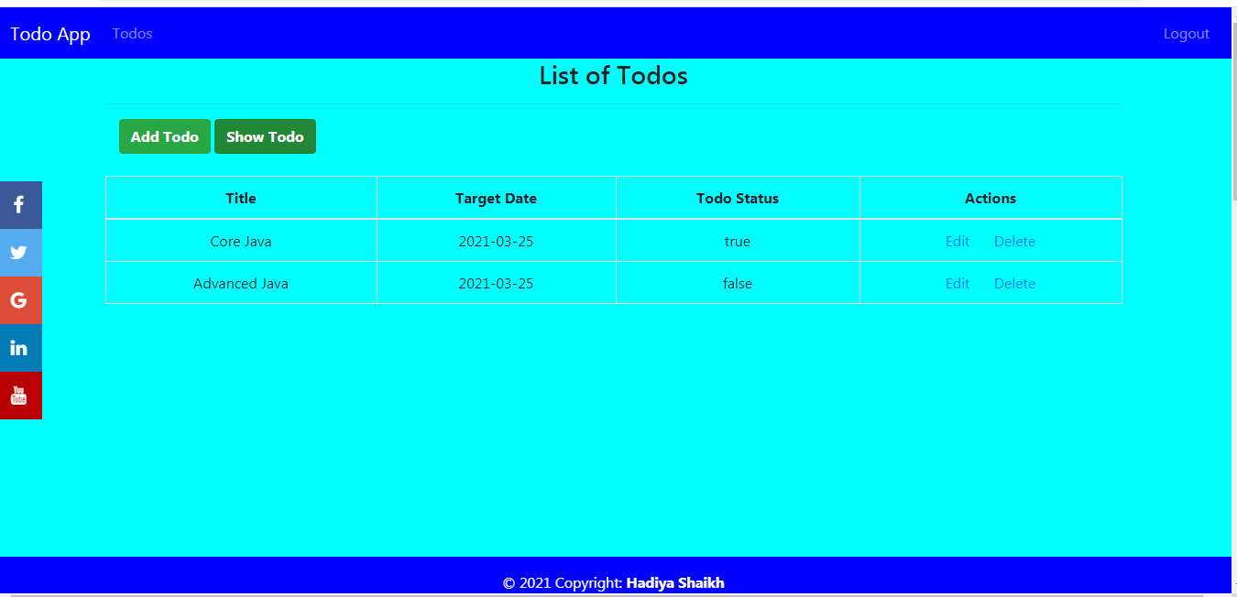

***Fig f. List of New To-do***

* **Edit Link:**

After click on Edit link Edit To-do .Click on Save button it will save the edit data into To-do list

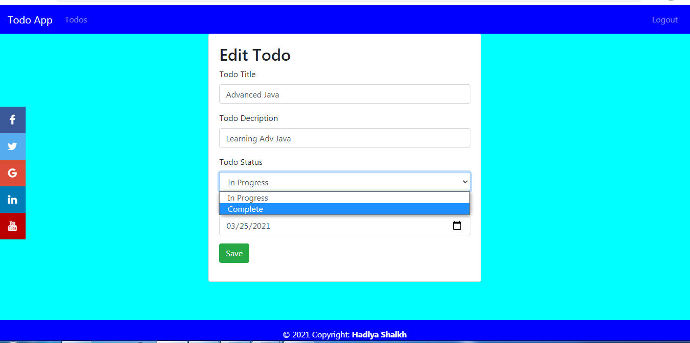

***Fig g. Edit To-do***

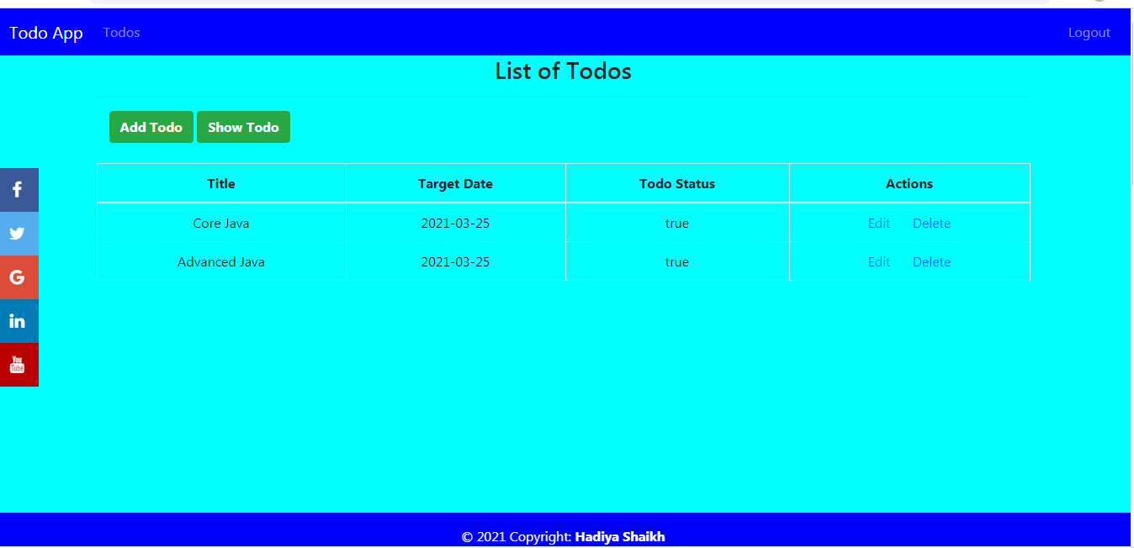

***Fig h. New Edit To-do List***

* **Delete Link:**

After click on Delete Link it will delete to-do from To-dos list.

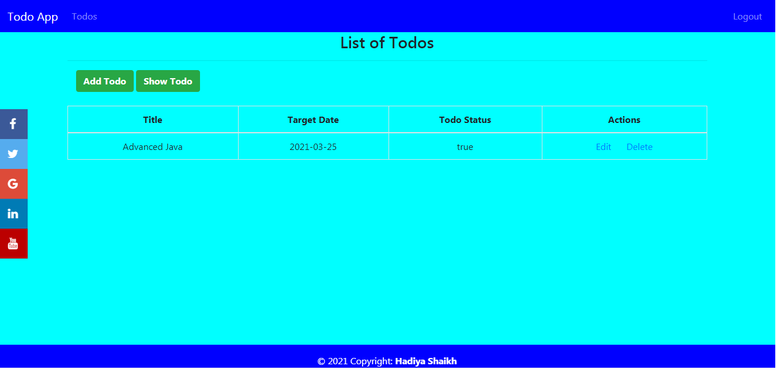

***Fig i. To-do List After delete some to-do***

1. **Logout**

After click on Logout it will redirect to Login Page.



***Fig j. Login page***

***To-do Application***